**RIPHAH INTERNATIONAL UNIVERSITY, ISLAMABAD**



**Lab # 2**

**Bachelors of Computer Science – 6th Semester**

**Subject: Operating System**

**Submitted to: Ms. Kausar**

**Submitted by: Javeria Inam_39977**

**Date of Submission: 03- Sep -2024**

**TASK:1**

* Start by creating two directories named OS_Course and OS_Lab.

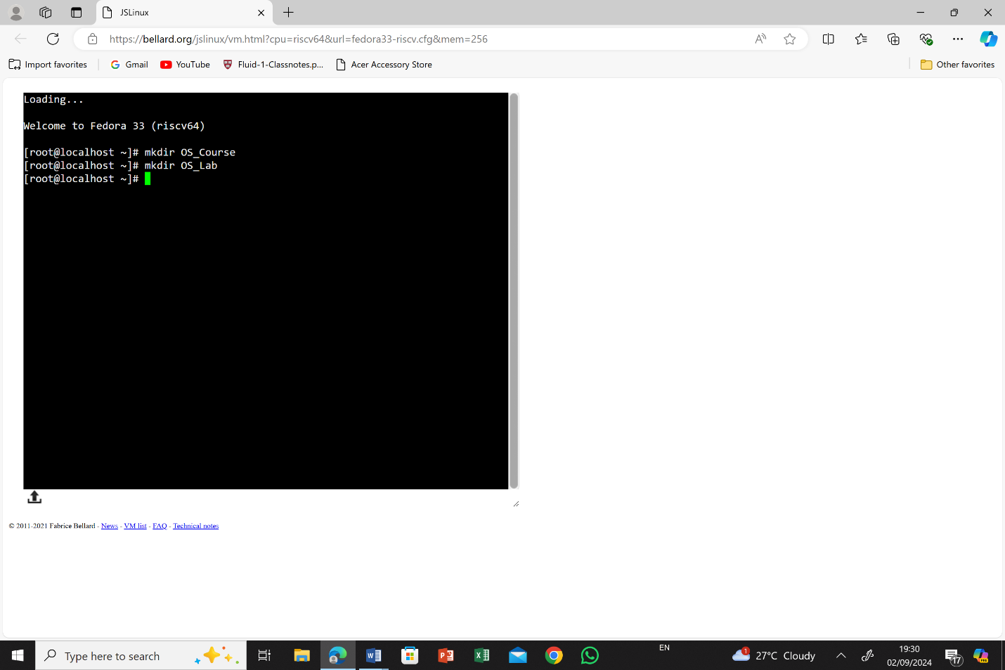

* After creating these directories, switch to the OS_Lab directory.

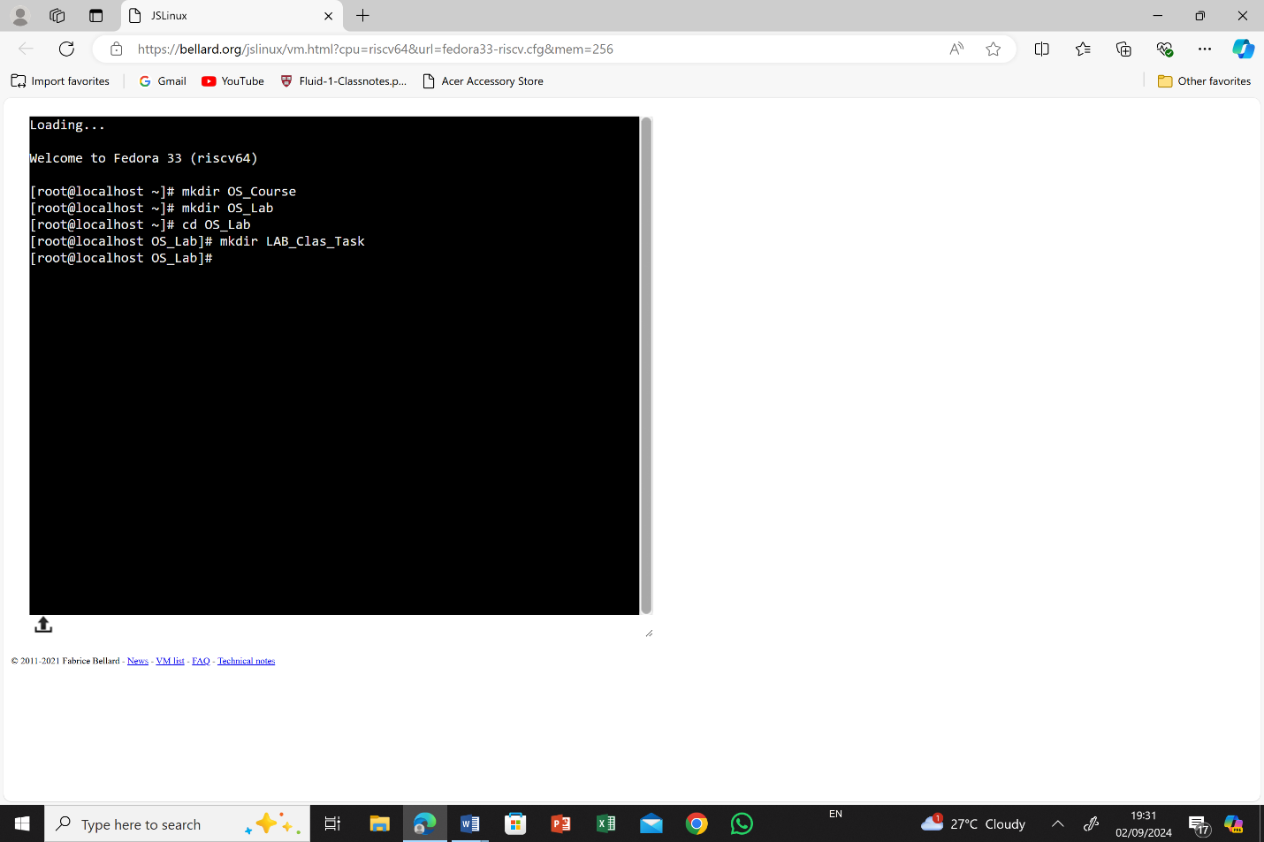

* Within OS_Lab, create three more directories named **LAB_Class_Task, LAB_Activities, and Lab_Practice**.

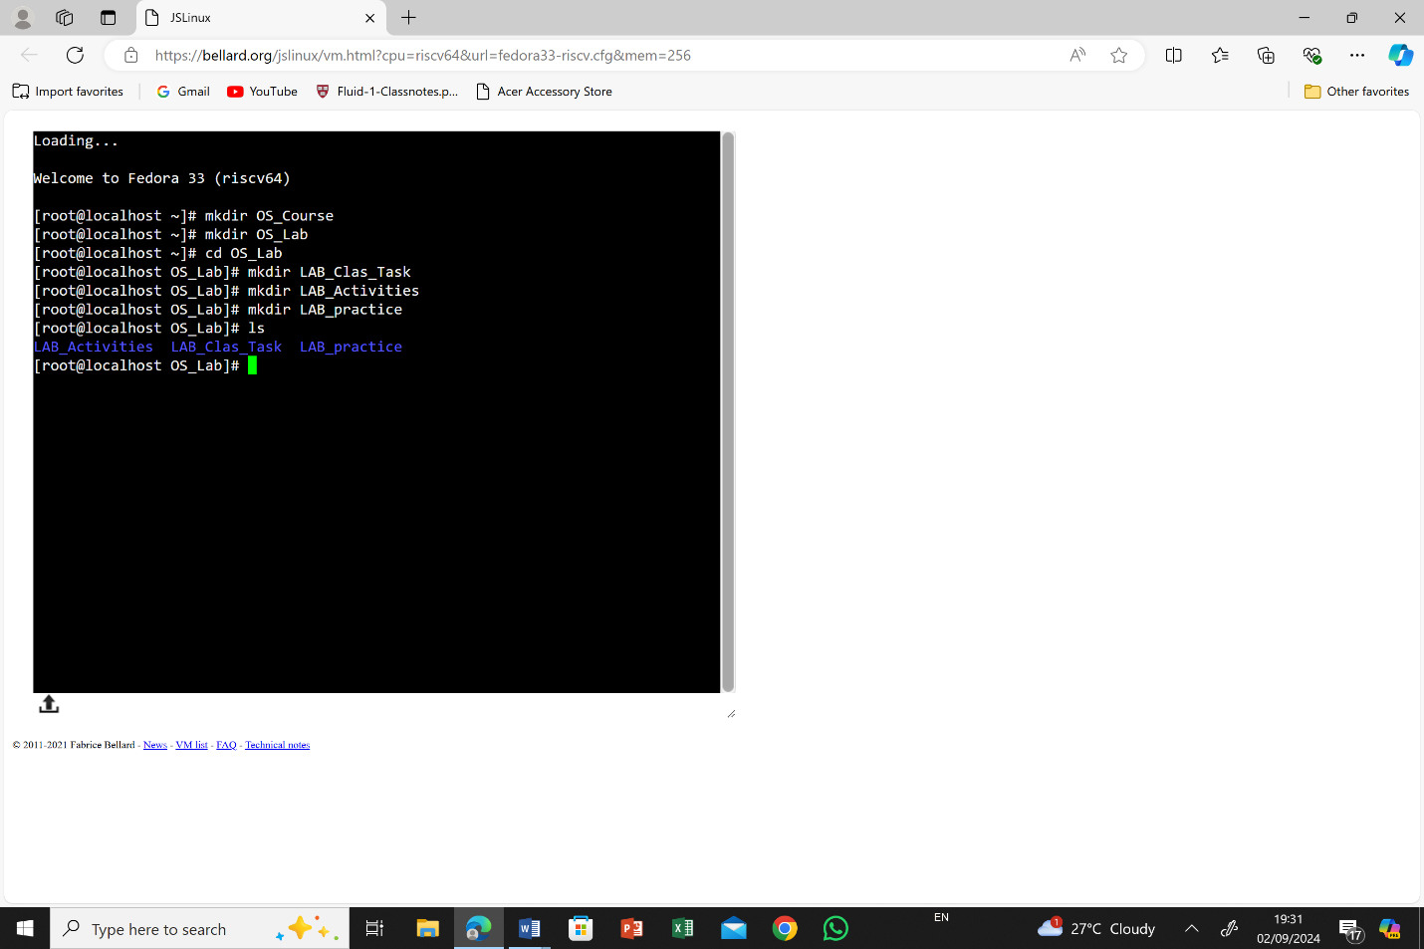

* Go into the **Lab_Practice** directory and create a file named example.cpp.

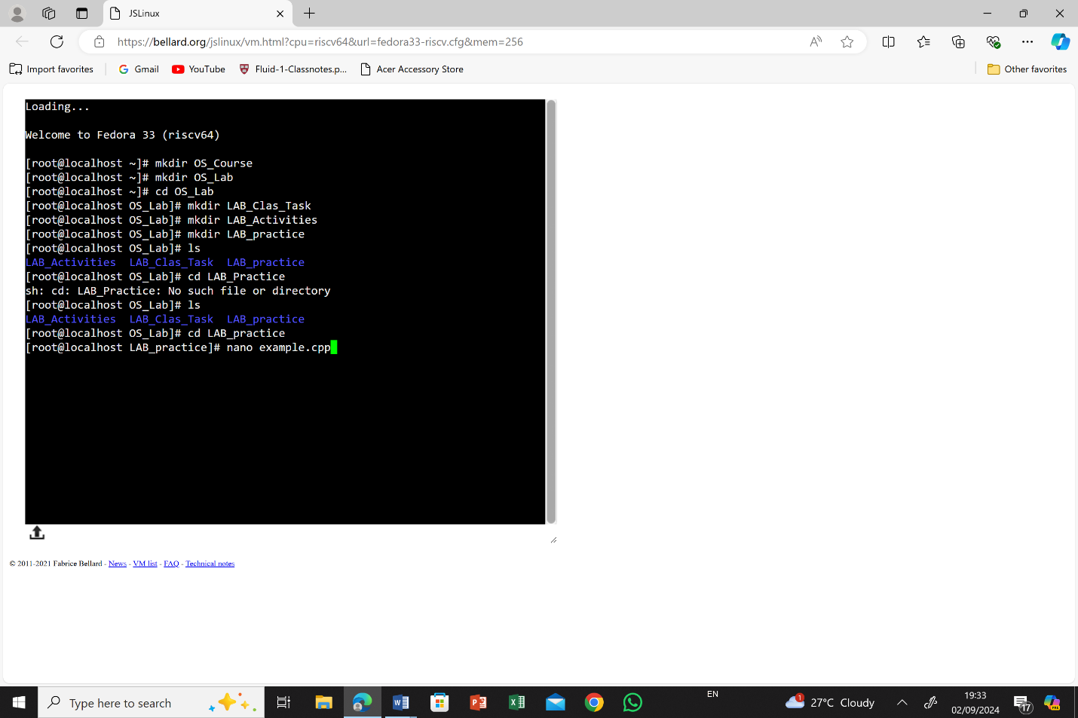

* This file should be empty and will be used for practice later.

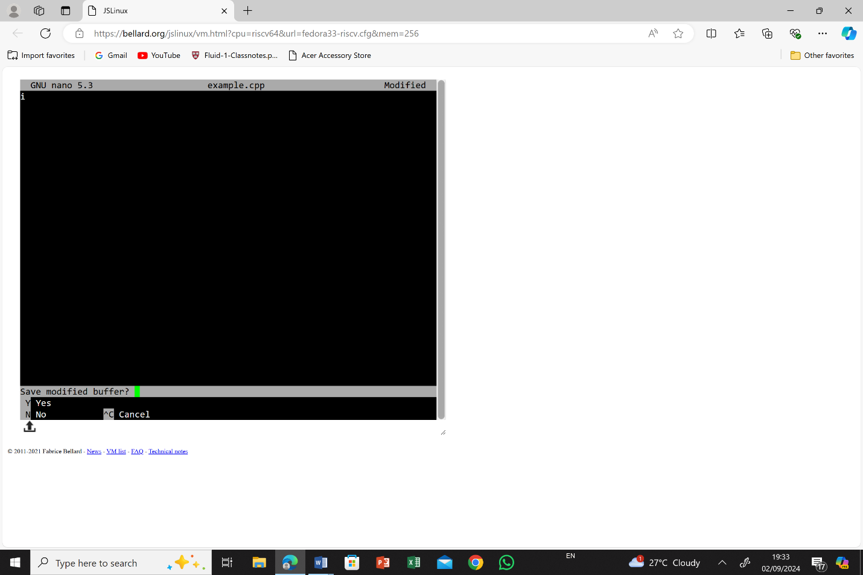

* Move back to your home directory.

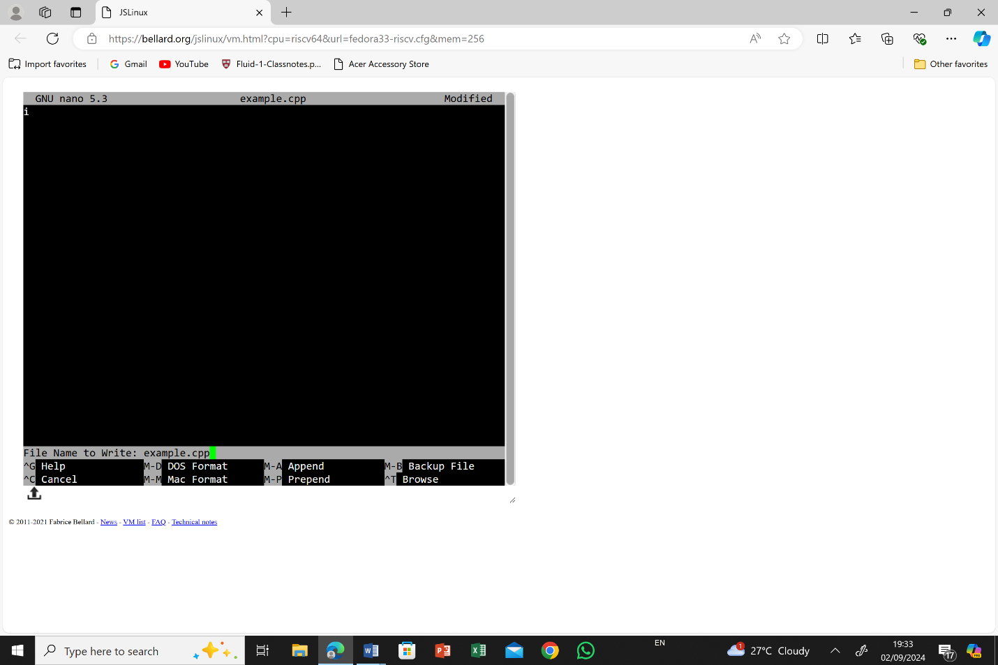

**TASK: 2**

**Absolute Path:**

* An absolute path specifies the location of a file or directory from the root directory. It provides the complete path, starting from the root (/ on Unix/Linux or the drive letter like C:\ on Windows), and lists each directory leading to the target file or directory.
* **Example:**
  + 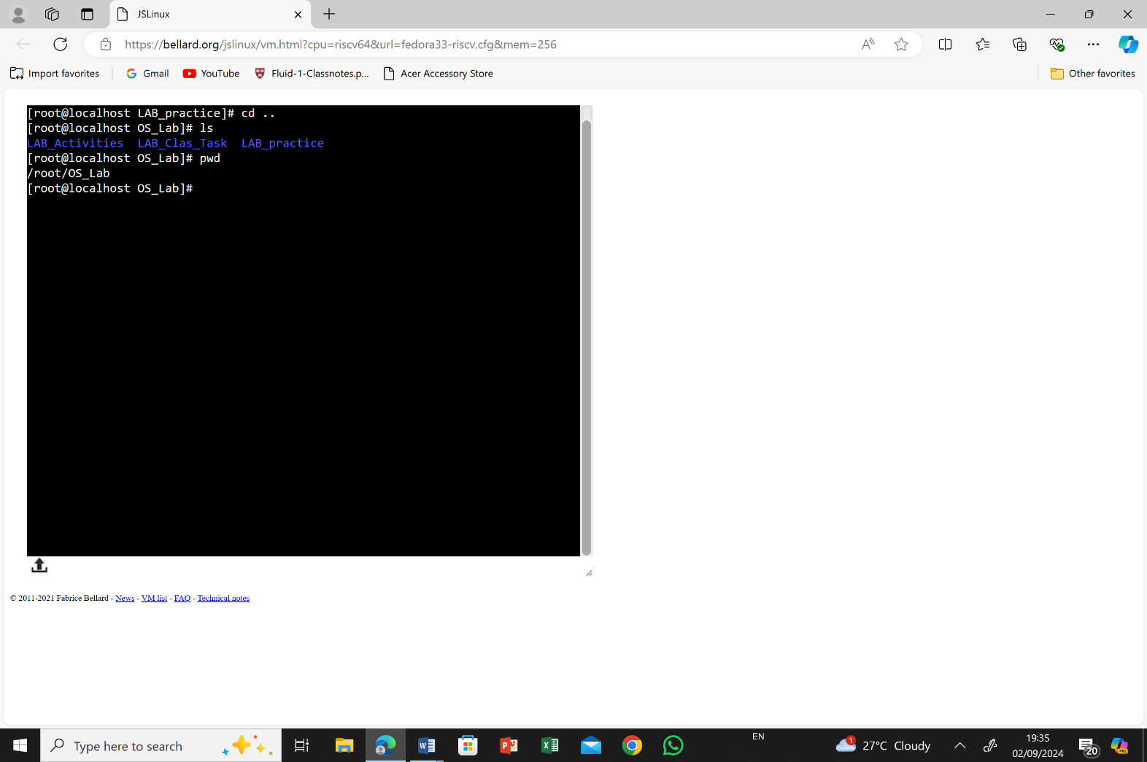On a Windows system: **C:\Users\User\Documents\LAB_Activities**

**Relative Path:**

* A relative path specifies the location of a file or directory in relation to the current directory. It does not start from the root directory but rather from the directory you are currently working in.
* **Example:**
  + 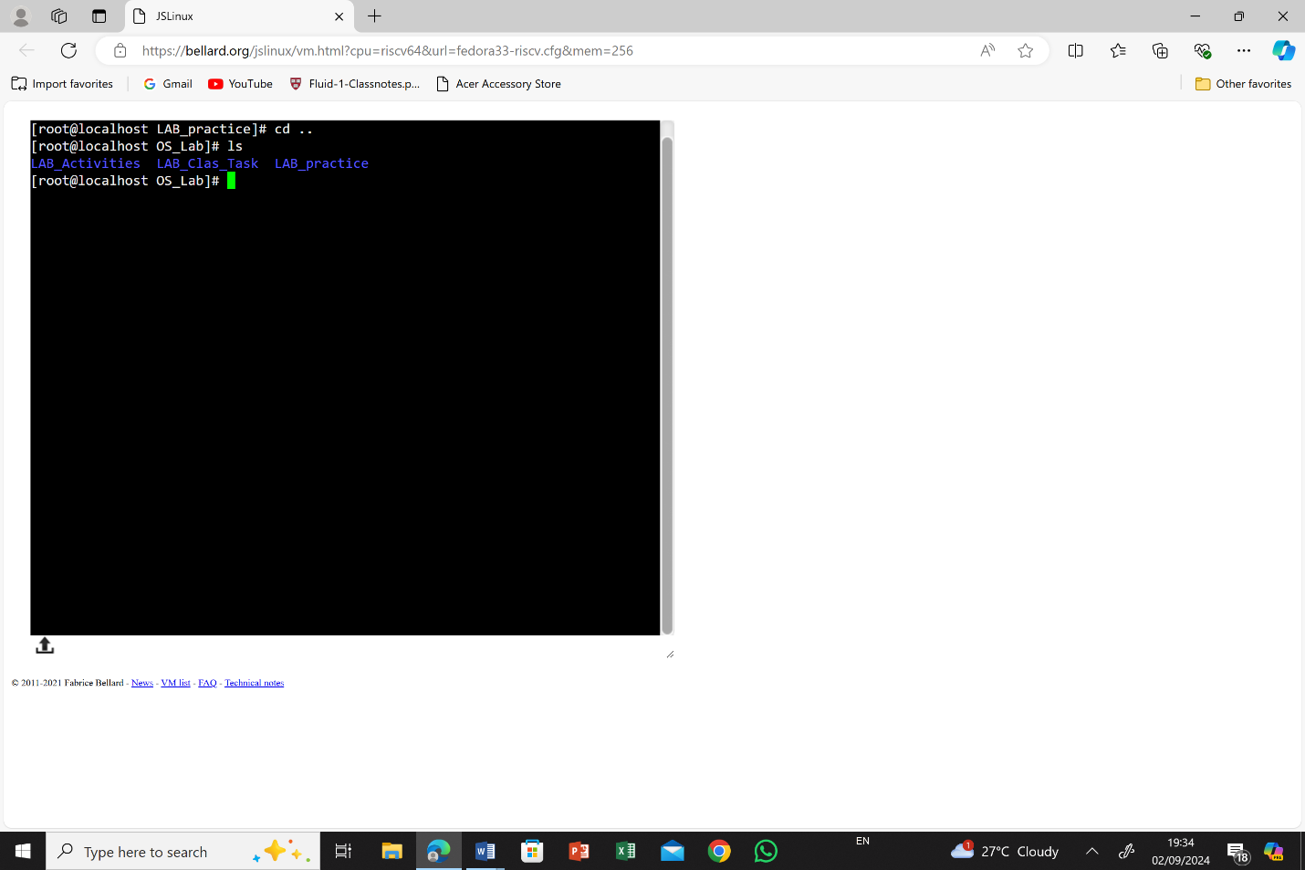If you are in the **Lab_Practice** directory and want to access a file in **LAB_Activities:**

**Current Directory:** **Lab_Practice**

To access the **LAB_Activities** directory from **Lab_Practice** using a **relative path**, you would move up one level to the parent directory and then down into the **LAB_Activities** directory. The relative path would be:

**Cd ..**

**Cd LAB_Activities**

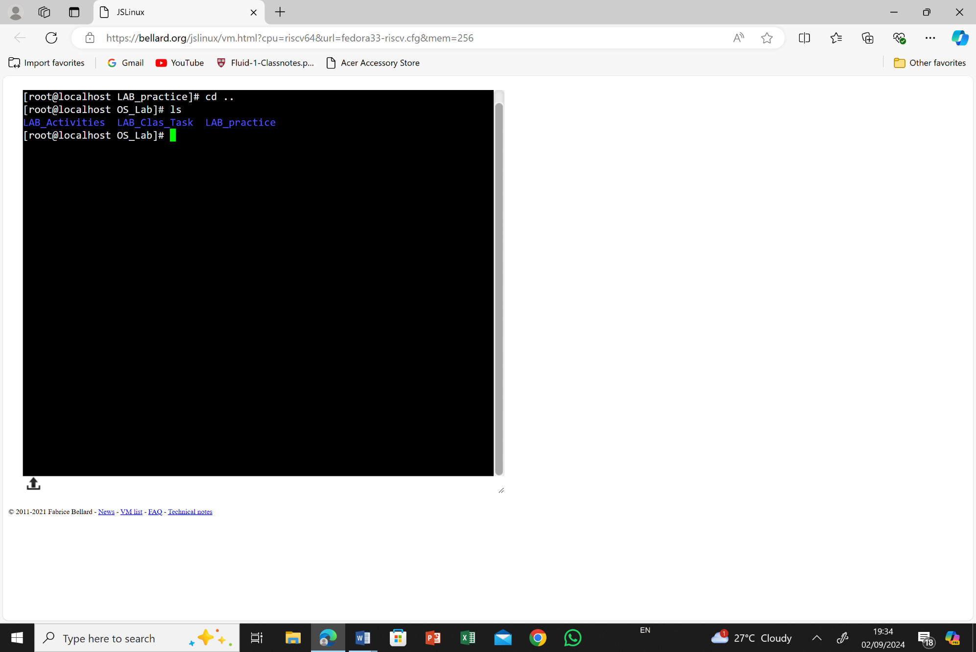

**TASK: 3**

When you perform a hard shutdown by holding the “power button”, your computer abruptly loses power, forcing all processes to stop. When you power it back on, the system goes through the BIOS/UEFI check, then loads the operating system from the storage drive into memory. If no errors occurred during the forced shutdown, the computer can start up quickly, bringing you directly to the login screen or desktop without any additional delays.